Sales Trends Analysis Report

Introduction
This report presents a comprehensive analysis of the e-commerce sales dataset to identify key business trends, product performance, customer purchasing behaviour, and regional sales patterns. The analysis focuses on sales trends, profitability, category performance, and geographic insights to support data-driven business decision-making.

Sales Trends Analysis
Yearly Sales Trends
The yearly sales analysis shows an overall upward trend in business performance over time.
Year-wise Sales:
- 2014- 484,247.50
- 2015- 470,532.51
- 2016- 609,205.60
- 2017- 733,215.26

Key Insights Sales experienced a slight decline in 2015 compared to 2014.
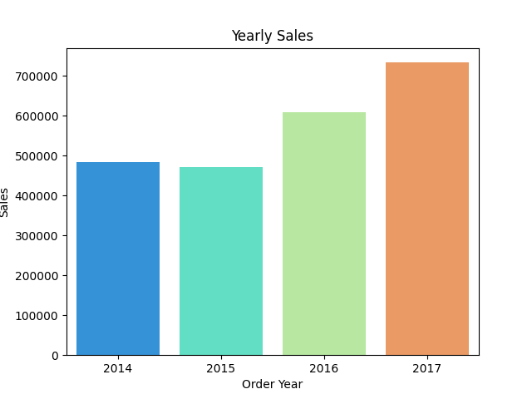
Significant growth was observed from 2016 onward, indicating improved business performance and increasing customer demand.
2017 recorded the highest sales, making it the best-performing year in the dataset.
The consistent growth trend during the later years suggests successful market expansion and stronger customer engagement over time.

Monthly Sales Trends
The analysis revealed strong seasonality in customer purchasing behaviour across the year.
Best Performing Months
- November
- December
- September
These months recorded the highest overall sales, indicating increased customer spending during the year-end and festive shopping season.
Lowest Performing Months
- January
- February
- April
Sales activity was comparatively lower during the beginning of the year, suggesting reduced post-holiday consumer spending.
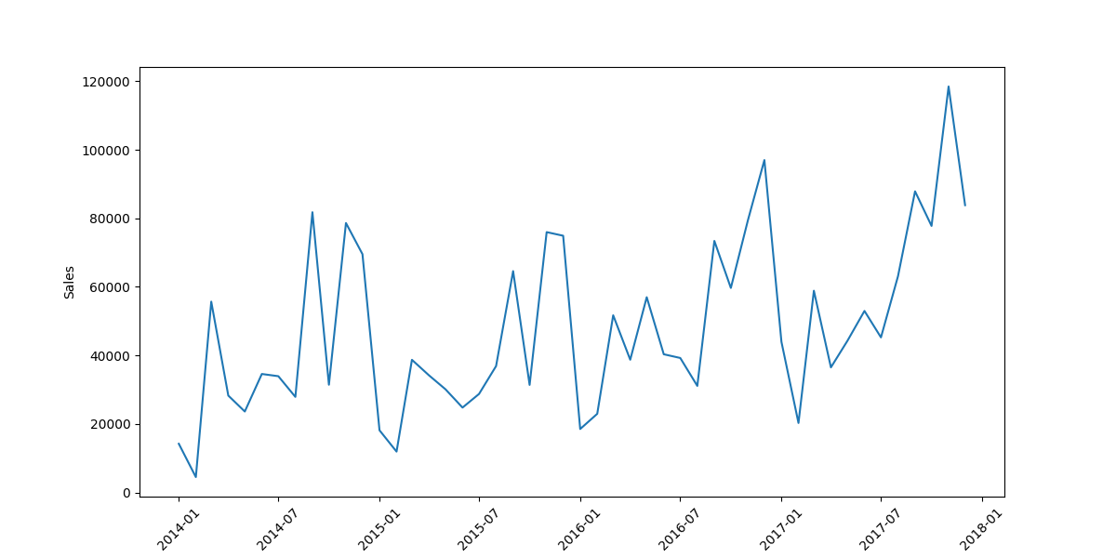

Key Observation
A clear increase in sales was observed during the final quarter of the year, highlighting the impact of holiday shopping and seasonal demand patterns on overall business performance.

Category Performance Analysis
Revenue Contribution by Category
The sales distribution across categories was relatively balanced, although Technology contributed slightly higher revenue than the other categories.
- Technology- 36.4%
- Furniture- 32.3%
- Office Supplies- 31.3%

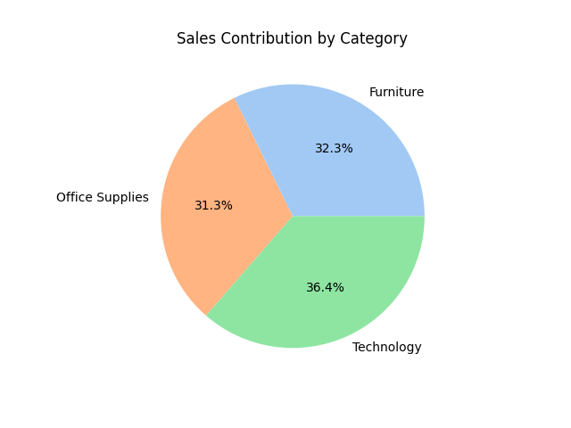

Key Findings
Technology emerged as the highest revenue-contributing category.
Office Supplies generated the highest sales volume, indicating frequent customer purchases and strong recurring demand.
The balanced distribution across categories reflects a diversified product portfolio.

Best-Selling Sub-Categories
The highest-performing sub-category within each major category was identified as follows:
- Technology- Phones
- Furniture- Chairs
- Office Supplies- Storage
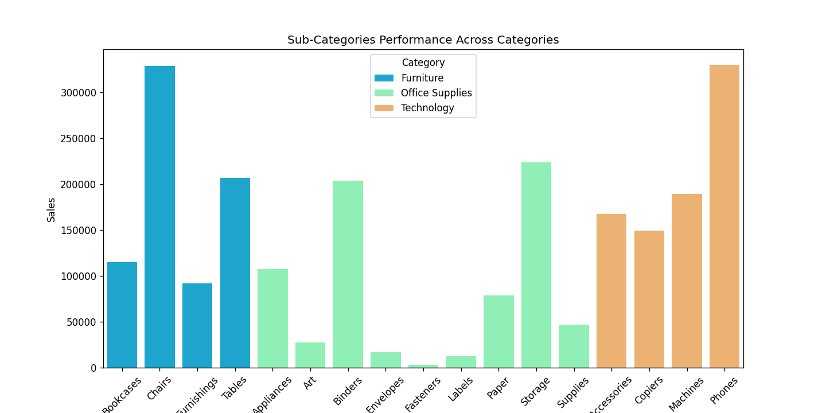

Insights
Phones generated significant revenue within the Technology category, reflecting strong demand for communication and electronic products.
Chairs dominated Furniture sales, suggesting consistent demand for office and home seating solutions.
Storage products performed strongly within Office Supplies due to their broad utility across customers and businesses.

Top Revenue-Generating Products
The following products generated the highest sales revenue:
Rank | Product Name | Sales
1. | Canon imageCLASS 2200 Advanced Copier | 61,599.82
2. | Fellowes PB500 Electric Punch Plastic Comb Binding Machine with Manual Bind | 27,453.38
3. | Cisco TelePresence System EX90 Videoconferencing Unit | 22,638.48
4. | HON 5400 Series Task Chairs for Big and Tall | 21,870.58
5. | GBC DocuBind TL300 Electric Binding System | 19,823.48
Key Findings
Technology products dominated the top revenue-generating product list.
High-value office equipment and communication devices contributed significantly to overall sales revenue.
Furniture products also appeared among top-performing products, indicating stable demand across categories.

Profitability Analysis
Product profitability analysis revealed that high sales volume does not always guarantee strong profitability.

Key Insights
The Canon imageCLASS 2200 Advanced Copier generated both high sales and strong profits, making it one of the most valuable products in the dataset.
Certain products generated high revenue but weak or negative profit margins, indicating possible over-discounting or pricing inefficiencies.
Products with higher discounts generally showed lower profitability, suggesting that excessive discounting negatively impacts business margins.
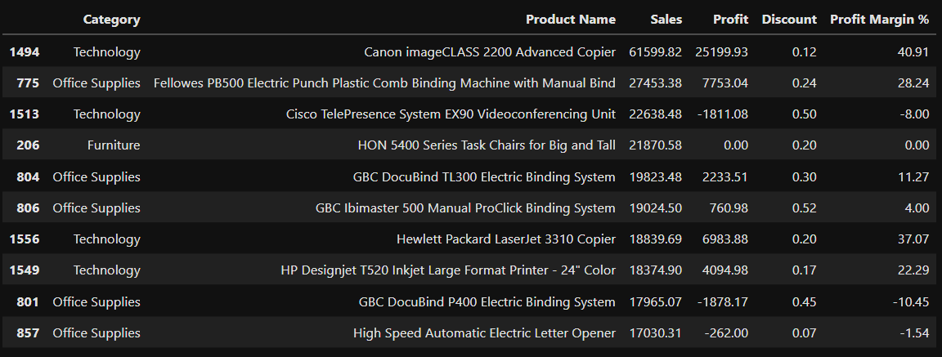

Business Implications
The findings emphasize the importance of monitoring both revenue and profitability together rather than focusing solely on sales growth.

Geographic Sales Performance
Best Performing States

- California
- New York

These states consistently recorded the highest sales performance across categories, indicating strong market demand and customer concentration.

Under-Performing States

- Wyoming
- North Dakota
- West Virginia

These regions recorded comparatively lower sales activity and customer engagement.

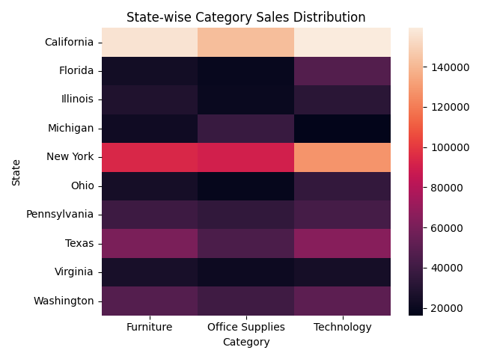

Regional Insights
Technology products performed exceptionally well in high-revenue states such as California and New York.
Furniture and Office Supplies showed relatively stable demand across multiple regions.
Significant regional variation in category performance suggests opportunities for region-specific inventory and marketing strategies.

Customer and Regional Behaviour Insights
Repeat purchase behaviour was stronger in certain states, indicating varying levels of customer retention and regional engagement.
Sales concentration was higher in urban and economically active states, reflecting stronger purchasing power and customer demand.
Regional category preferences indicate that targeted marketing strategies could improve customer engagement and conversion rates.

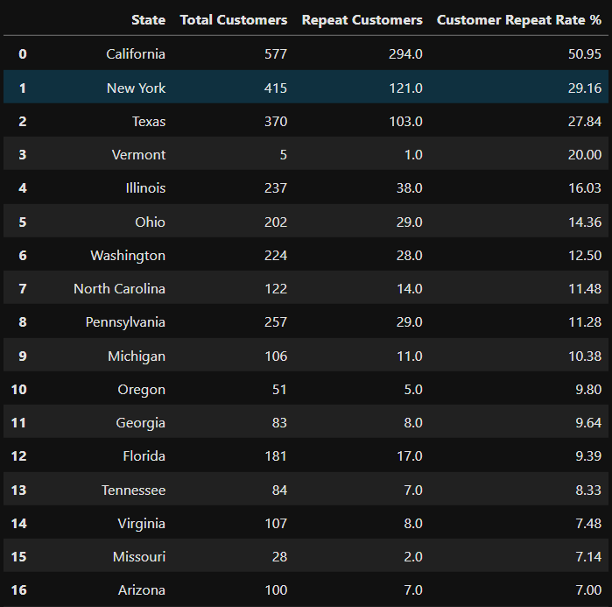

Business Recommendations
Sales and Marketing Recommendations
Increase promotional campaigns during high-performing months such as November and December to maximize seasonal revenue opportunities.
Implement targeted digital marketing campaigns for Technology products in high-performing states.
Introduce loyalty programs and personalized offers to improve repeat customer purchases.

Profitability Recommendations
Reduce excessive discounting on products with consistently low or negative profit margins.
Promote high-margin products through premium positioning and targeted advertising.
Use product bundling strategies to increase average order value and improve profitability.

Logistics Recommendations
Prioritize inventory allocation and warehouse optimization in high-demand states such as California and New York.
Improve product availability and distribution efficiency in under-performing regions to support market expansion opportunities.

Conclusion
The analysis revealed strong seasonal sales patterns, balanced category performance, and significant regional variations in customer demand. Technology emerged as the leading revenue-generating category, while Office Supplies demonstrated strong sales volume. Although several products generated high revenue, profitability analysis highlighted the importance of managing discounts and pricing strategies effectively.
Overall, the dataset provided valuable business insights that can support strategic decision-making in sales optimization, regional expansion, customer targeting, and profitability improvement.

